Armageddon 1-lab1 Notes
CIDR: 10.108.0.0/16

Steps:
1.Create VPC:
- choose VPC and more,
- select VPC CIDR block,
- choose at least 2 AZ's (the RdDS DB, requires at least two),
- Set each subnet CIDR block,
- NAT gateway is not needed for this simple setup (pubic subnet EC2 will use IGW),
- S3 Gateway not needed,
- Enable DNS Hostnames & DNS Resolution
2. Create Security Group:
- This is for EC2 to be accessible by HTTP and SSH,
- Allows IPv4 anywhere for inbound HTTP and SSH (you can limit to your IP)
3. Policy & Roles that allows EC2 to get secret:
- For this will create the need permissions policy first, then attach it to the role along with the proper principal
- permission policy:
```{"Version": "2012-10-17","Statement": [{"Sid": "ReadSpecificSecret","Effect": "Allow","Action": ["secretsmanager:GetSecretValue"],"Resource": "arn:aws:secretsmanager:<REGION>:<ACCOUNT_ID>lab/rds/mysql*"}],
}
``
N.B. Ensure to make the necessary changes for <REGION> and <ACCOUNT_ID>, also take note of the lab/rds/mysql` as this needs to be the exact secrets name in Secrets Manager.
4. EC2 creations:
- Default setting for AMI (Amazon Linux 2023)
- Default instance type and settings
- create key pair
- Choose created VPC, public subnet, and public security group
- enable 'Auto-assign public IP'
- Double-check, pray, then launch instance
5. Attach role to instance:
- steps = Instance > Actions > Security > Modify IAM Role
- Then attach the role you just created under 'IAM Role'
- The click 'Update IAM Role'
6. Create RDS Database:
- Go to create database under 'Aurora and RDS'
- Go 'Full Configuration'
- Then "MySQL"
- Then Choose 'Free Tier'
- Choose DB Instance Identifier ('lab-mysql')
- Choose Master username ('admin')
- Then select 'Self-Managed' for 'Credentials management'
- Then create and remember your password ('TestArm432') {this a test, make your own}
- Then leave setting default until Connectivity, select "Connect to and EC2 compute resource"
- Choose the created EC2 under 'EC2 Instance'
- VPC should be automatically selected
- DB Subnet Group, choose automatic setup
- Public Access = 'No'
- For VPC Security Group check 'Create New'
- Enable Logs then 'Create Database'
7. Create Secret in Secrets Manager
- Under Secrets Manager, select 'Store a New Secret',
- 'Secret Type' is Credentials for Amazon RDS Database,
- Credentials, User name = 'admin' (or your choice),
- Credentials, Password = 'you specific password',
- Then select your created DB, then click next,
- Set Secret Name to be same as in policy and application script,,
- Then click until you reach review (leave configuration rotation as default),,
- Review and then 'Store' your secret.

Run these commands:
dnf install mariadb105 -y
aws secretsmanager get-secret-value --secret-id lab/rds/mysql
mysql -h <RDS_ENDPOINT> -u admin -p
systemctl start rdsapp
sudo systemctl restart rdsapp
sudo systemctl restart rdsapp

When you place the IP Address in the web browser, add the following command instead of “/init”; ***NOTE: this is going to literally add the phrase: “note=cloud_labs_are_real” to the screen. Part of the deliverables are to add three more sentences.
add?note=cloud_labs_are_real

Run these commands:
aws rds describe-db-instances --db-instance-identifier lab-mysql --query "DBInstances[].Endpoint"
aws secretsmanager get-secret-value \ --secret-id lab/rds/mysql
mysql -h <ENDPOINT> -u <USER> -p test
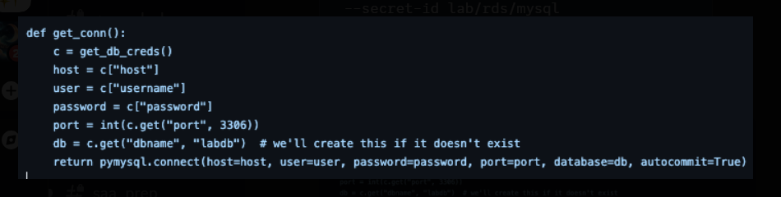

sudo systemctl restart rdsapp
add?note=cloud_labs_are_real

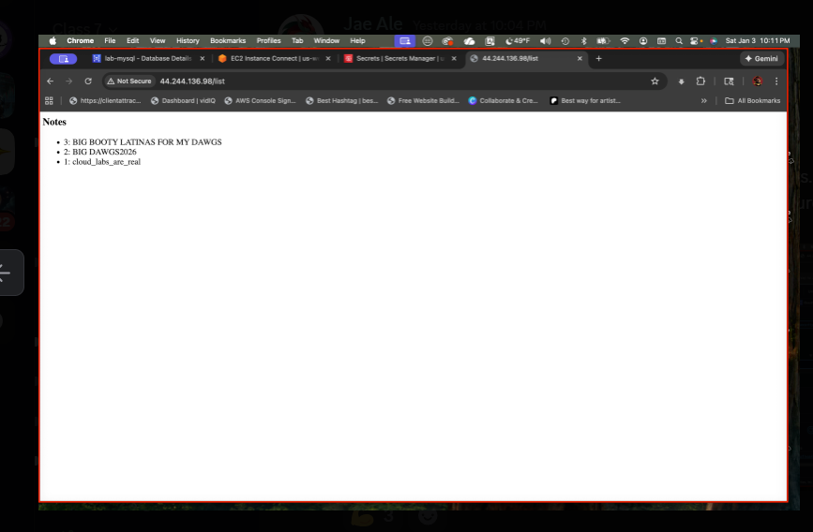
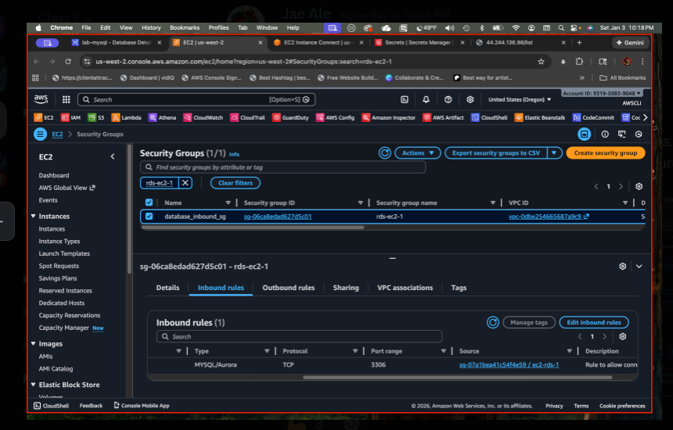

Additional Notes:
VPC
Inbound Rules
SSH Protocol: TCP Source: 0.0.0.0./0 IPV4 Anywhere Port: 22
HTTP Protocol: TCP Source: 0.0.0.0/0 IPV4 Anywhere Port: 80
Aurora and RDS > Databases > Create
- MSSQL > Full Configuration
- Edition > My SQL Community > Free Tier
DB identifier > “lab-mysql”
Master Username
“admin”
Credentials Management > Self-managed
Findings:
Note1: For managed databases, you need @ least 2-AZs for possibly high availability; For an Instance you can possibly get away with having only 1-AZ.
Note2: Regarding the policy: During the process, we didn’t have a principal role but it does not say who can do it.
Note3: IAM > Roles > Create Role
We had to use the “custom policy” because the system would not accept the “read specific secret”; The policy needs permissions.
We changed the policy to reference “specific secret” and we made it less broad
We are attaching the policy to a role and the EC2 instance can assume that role
To differentiate the naming reference in the name of the public EC2 instance that we used we added “2” to the instance name: lab-ec2-app2
Remember the jason.tf policies are different
(next page)

Policies
IAM > Policies > Create Policy
Specify permissions
Policy editor > choose “json”; input the modified policy from: Jae Ale in the policy editor
change the region to the current region you are using
change the account ID to your account ID
Note: In the policy editor, take the “Bash” off of the top of the script
Remember to add a colon in the statement and leading spaces:
region:<account id>:lab/rds/mysql
Review and create
Policy name: (we used the following) “dawgs_iam_ec2_policy”
Permission defined in this policy
Change nothing in this section
Ec2
Button on right side: choose turn-on “show remaining 460 services”
****Note: Use the policy Jae Ale put in the chat in:
IAM > Policies >(Policy Editor) >create policy
Policy Details > Policy Name: “dawgs_iam_ec2_policy
Create policy (button)
Go to ROLES (left side)
On left click > create roles

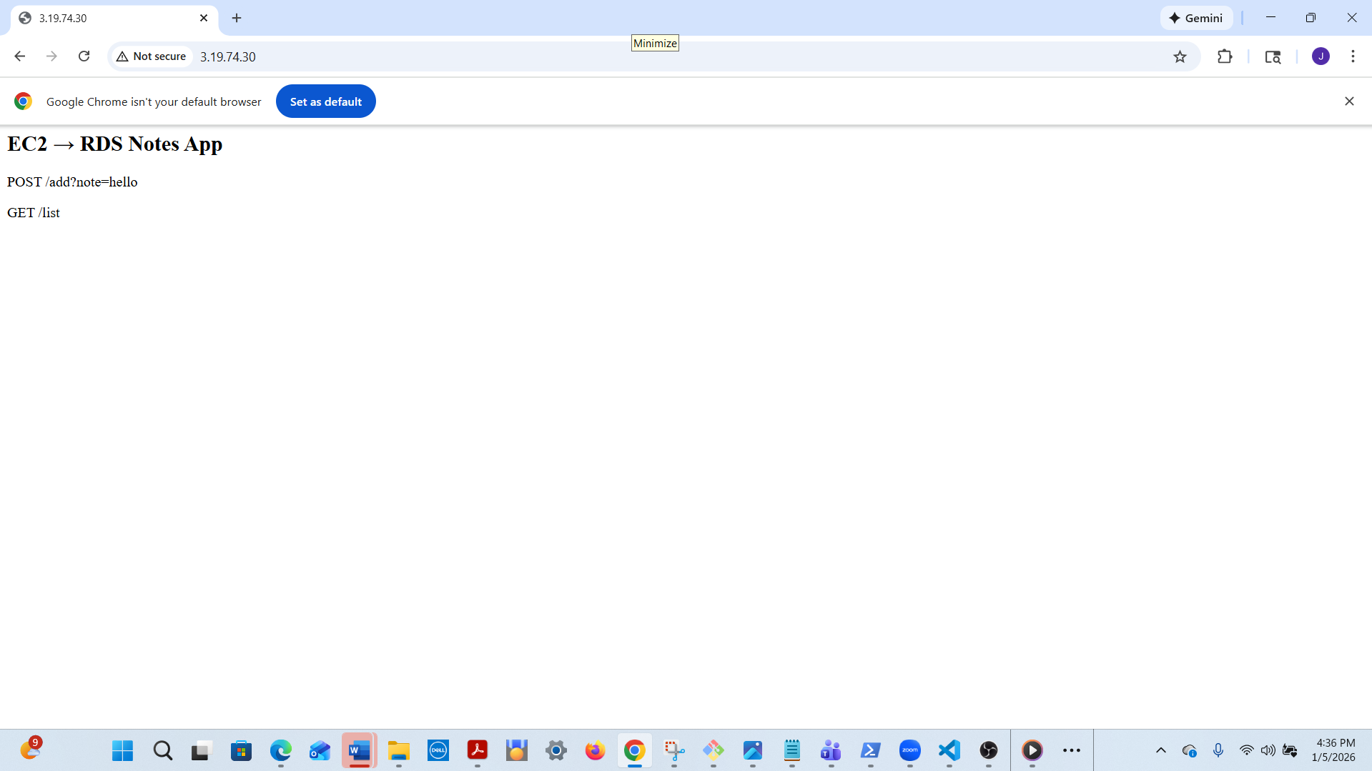

Database successfully created (see screenshot below)
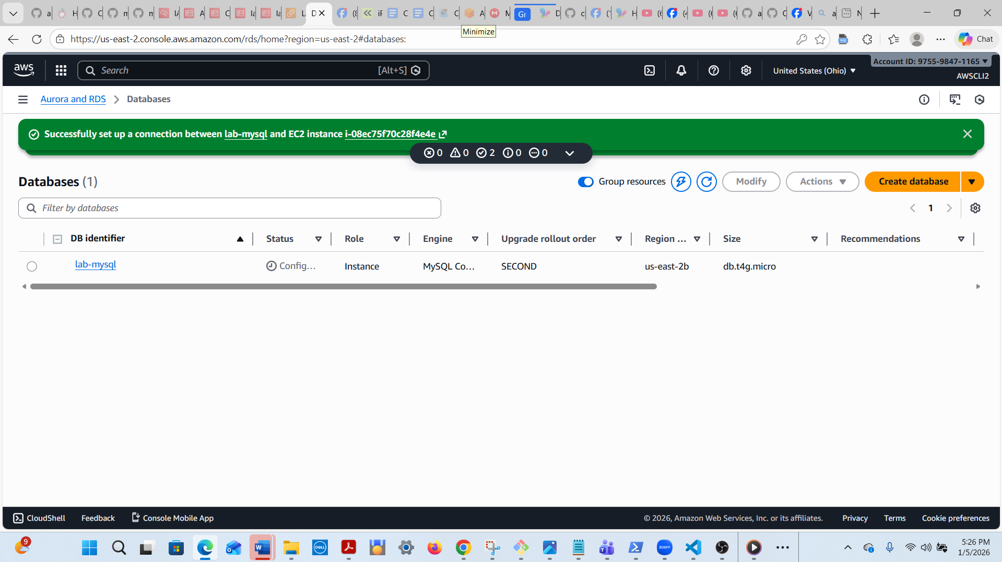

mysql -h lab-mysql.c1q82o4y6ju9.us-east-2.rds.amazonaws.com -u admin -p
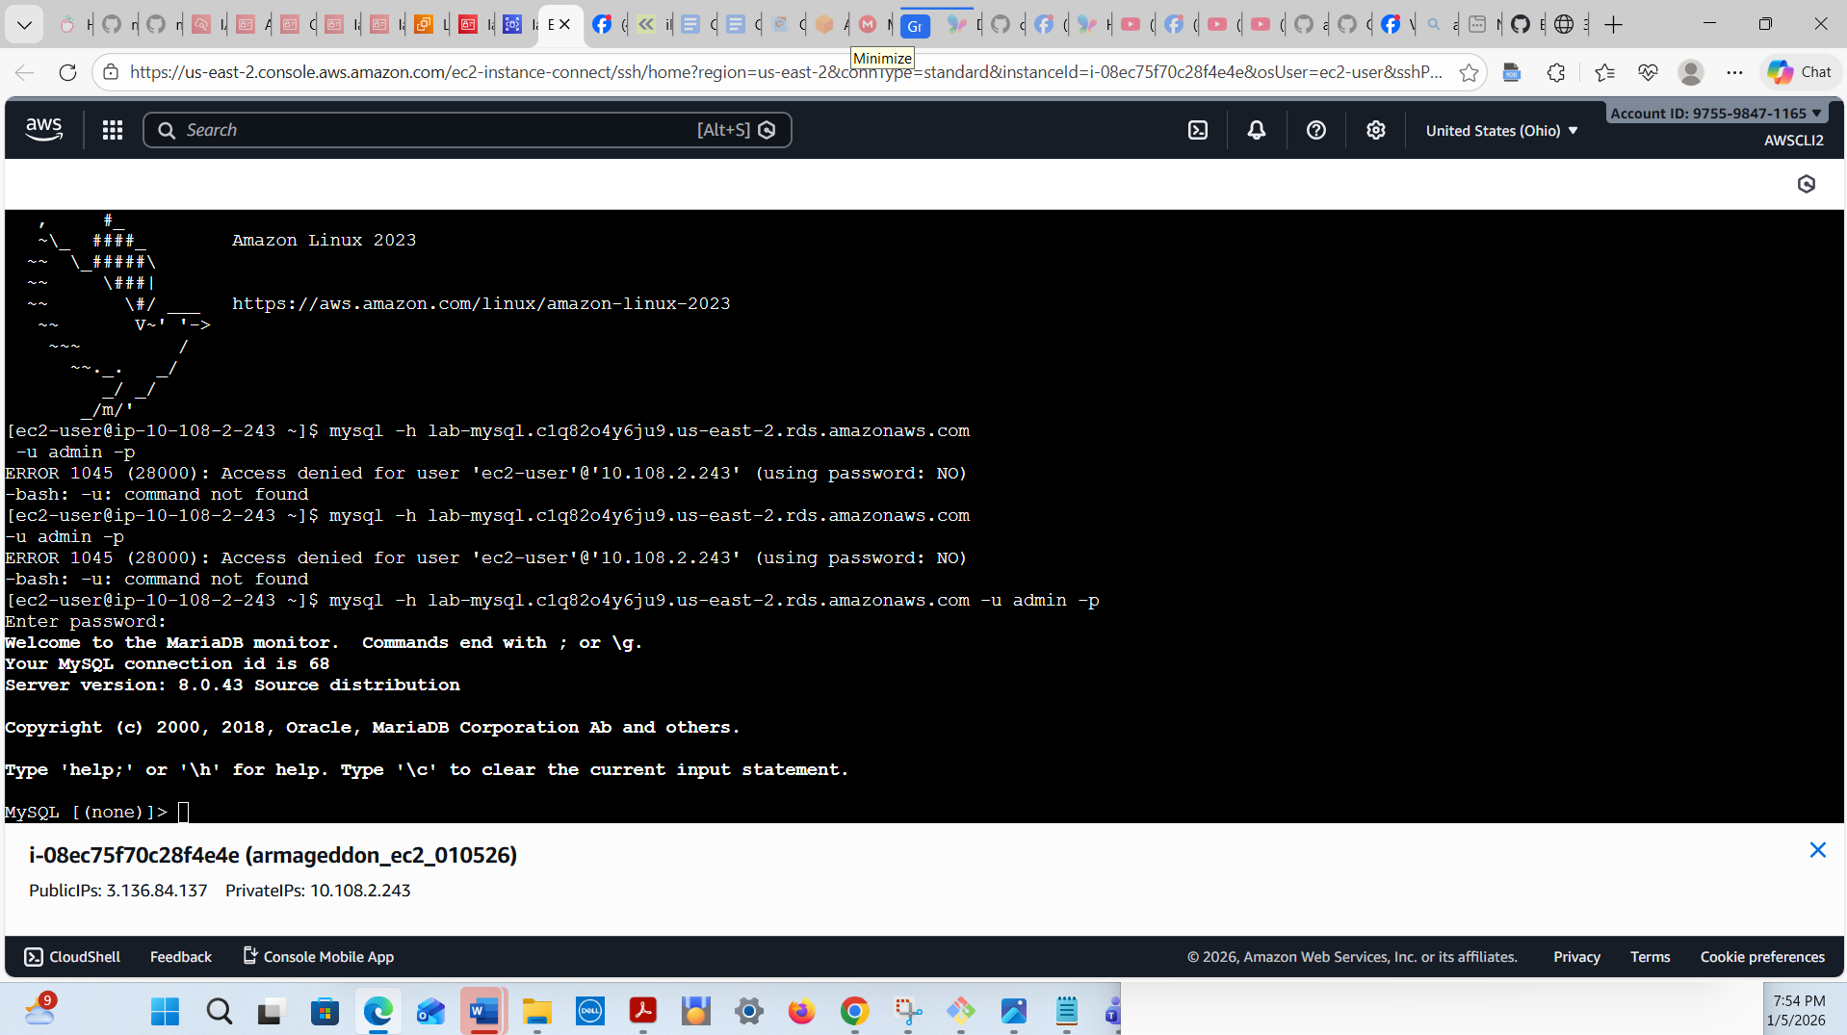

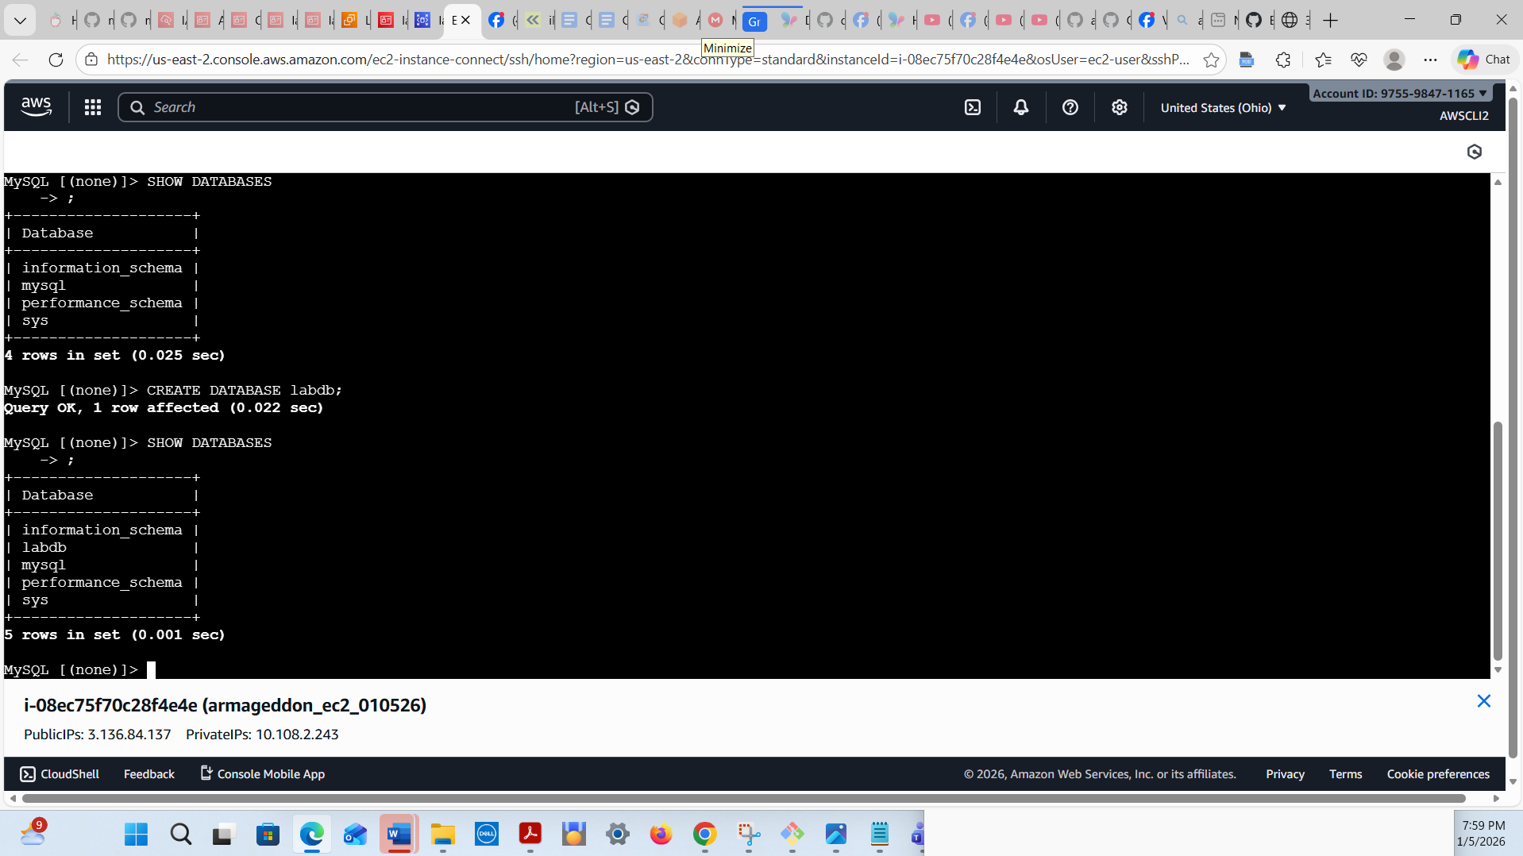
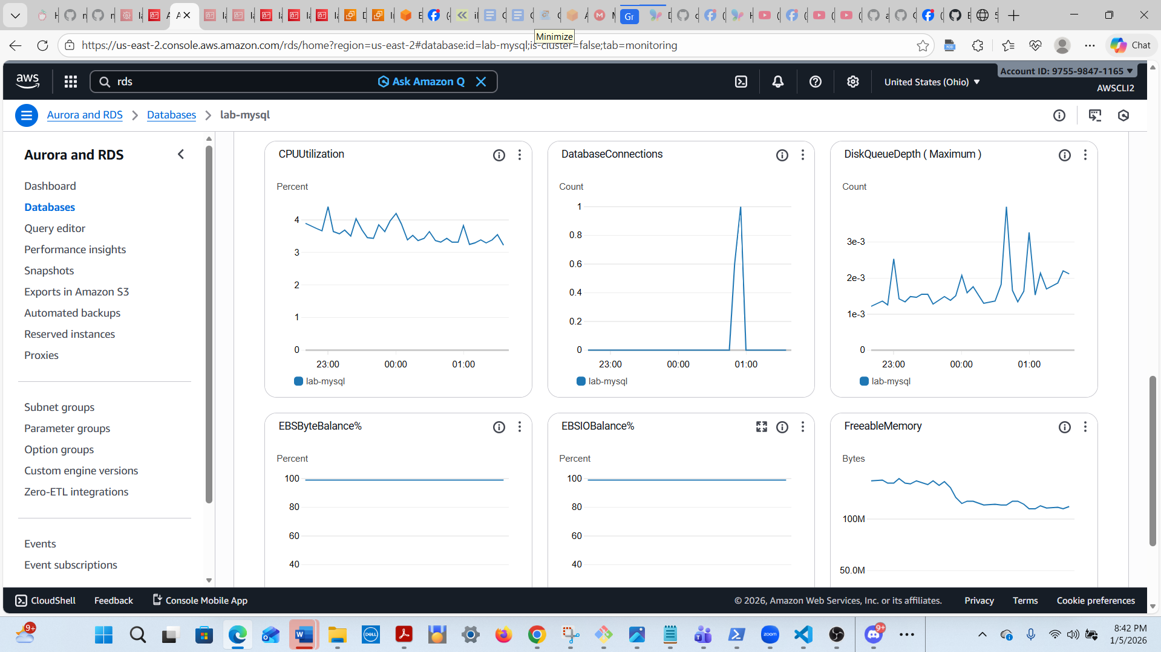

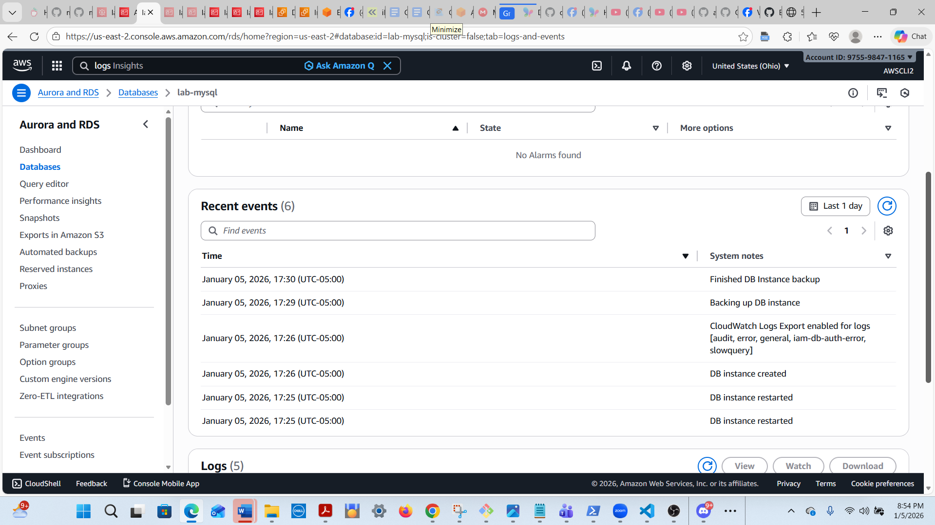
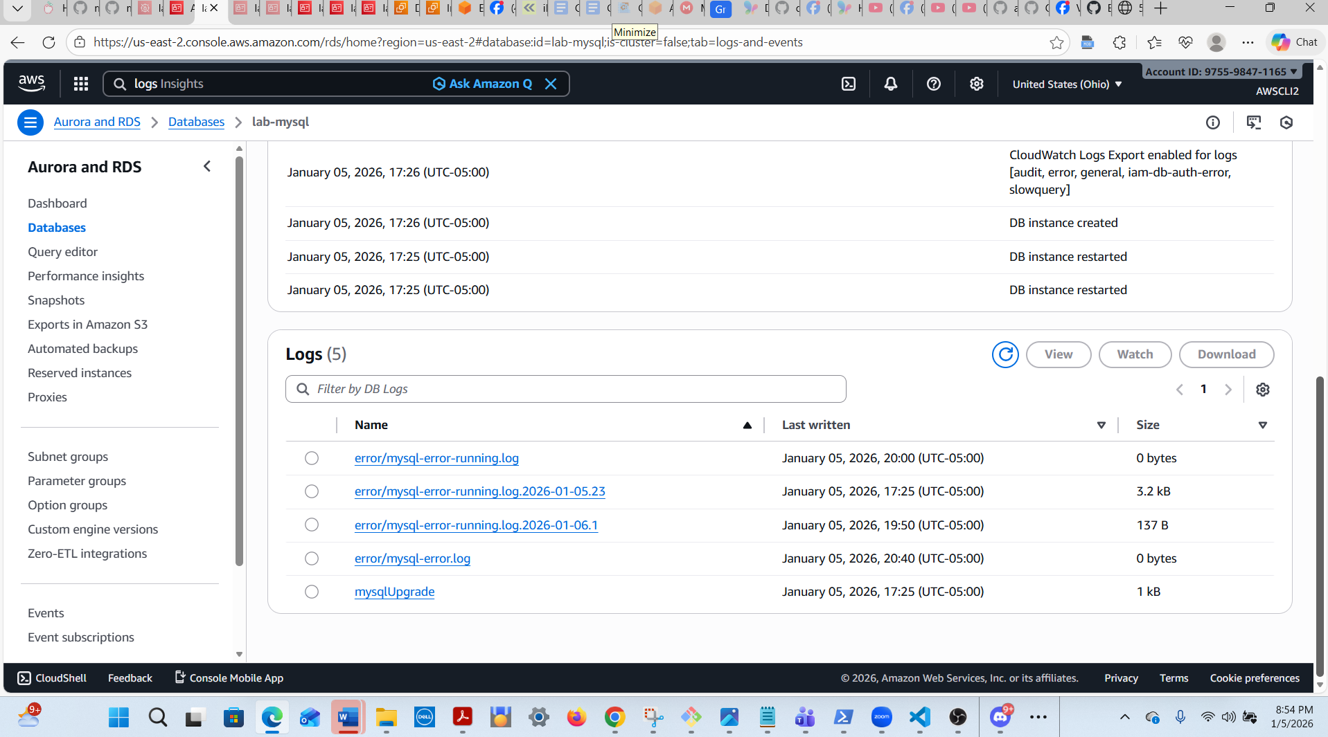

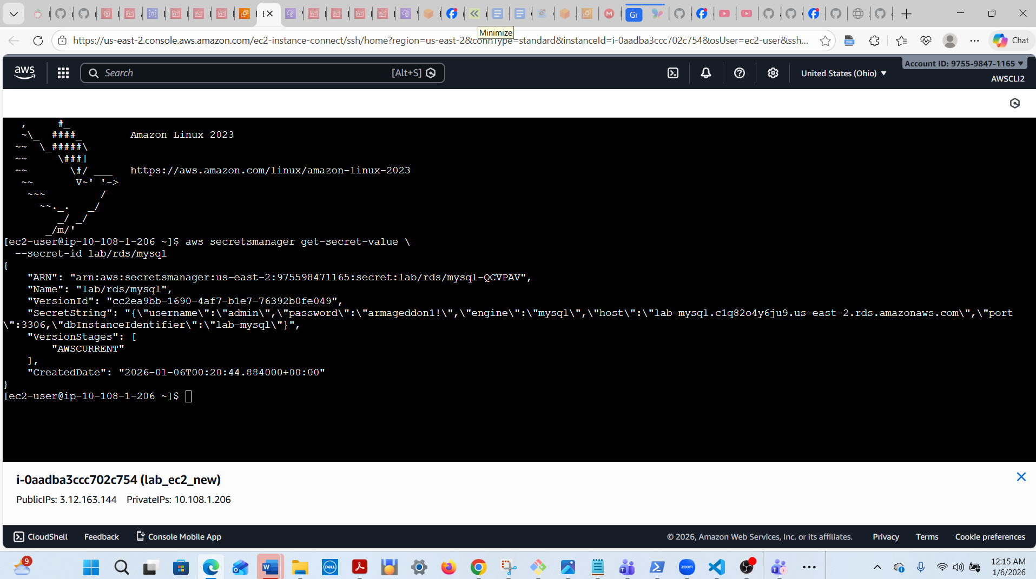

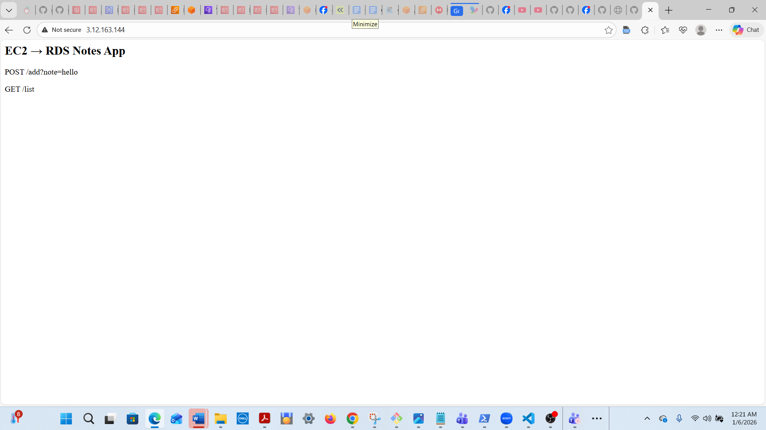

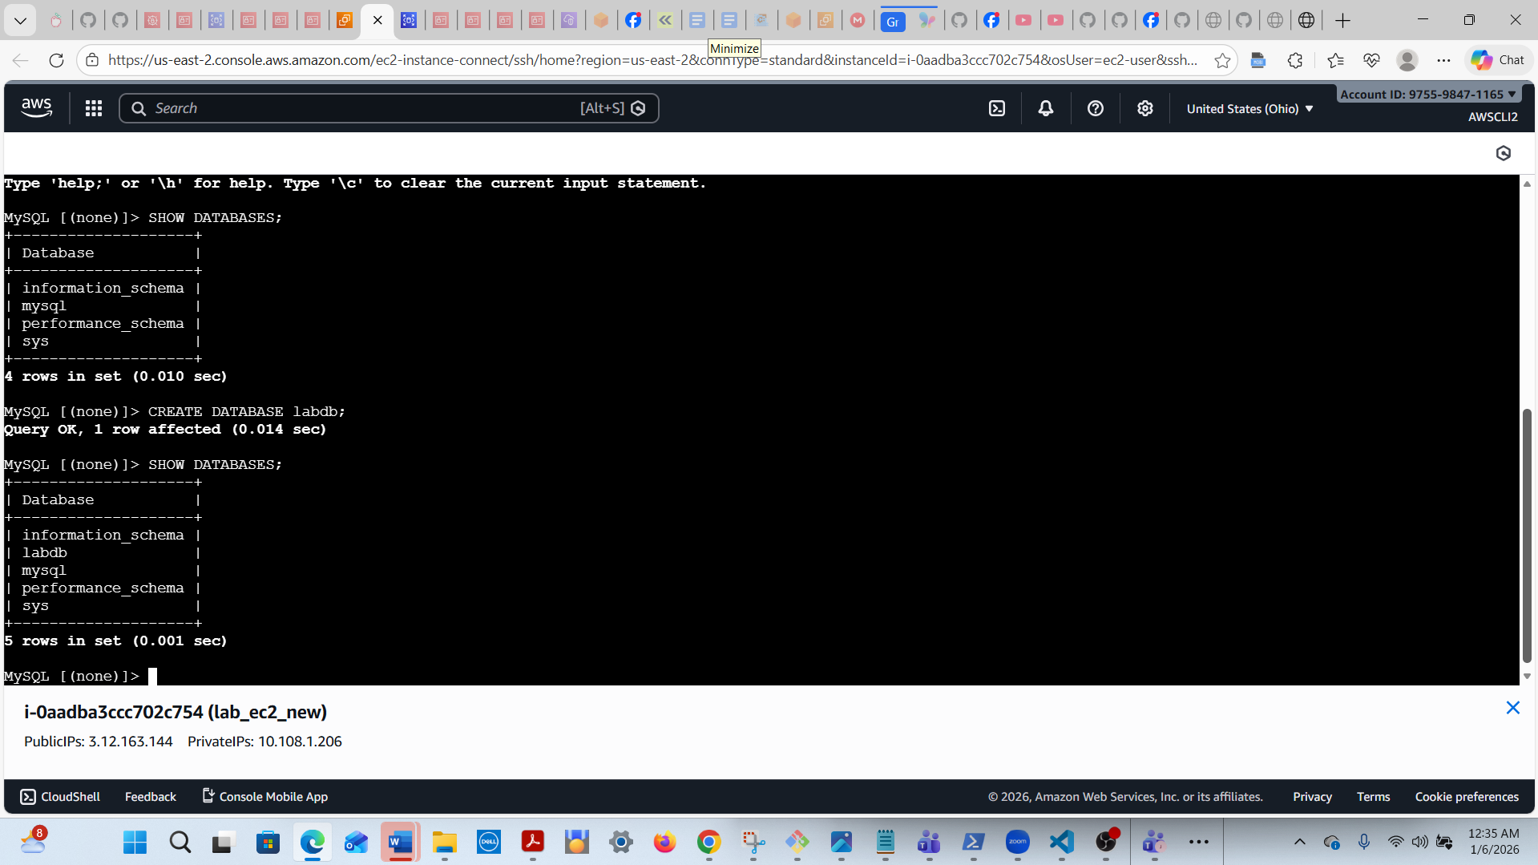

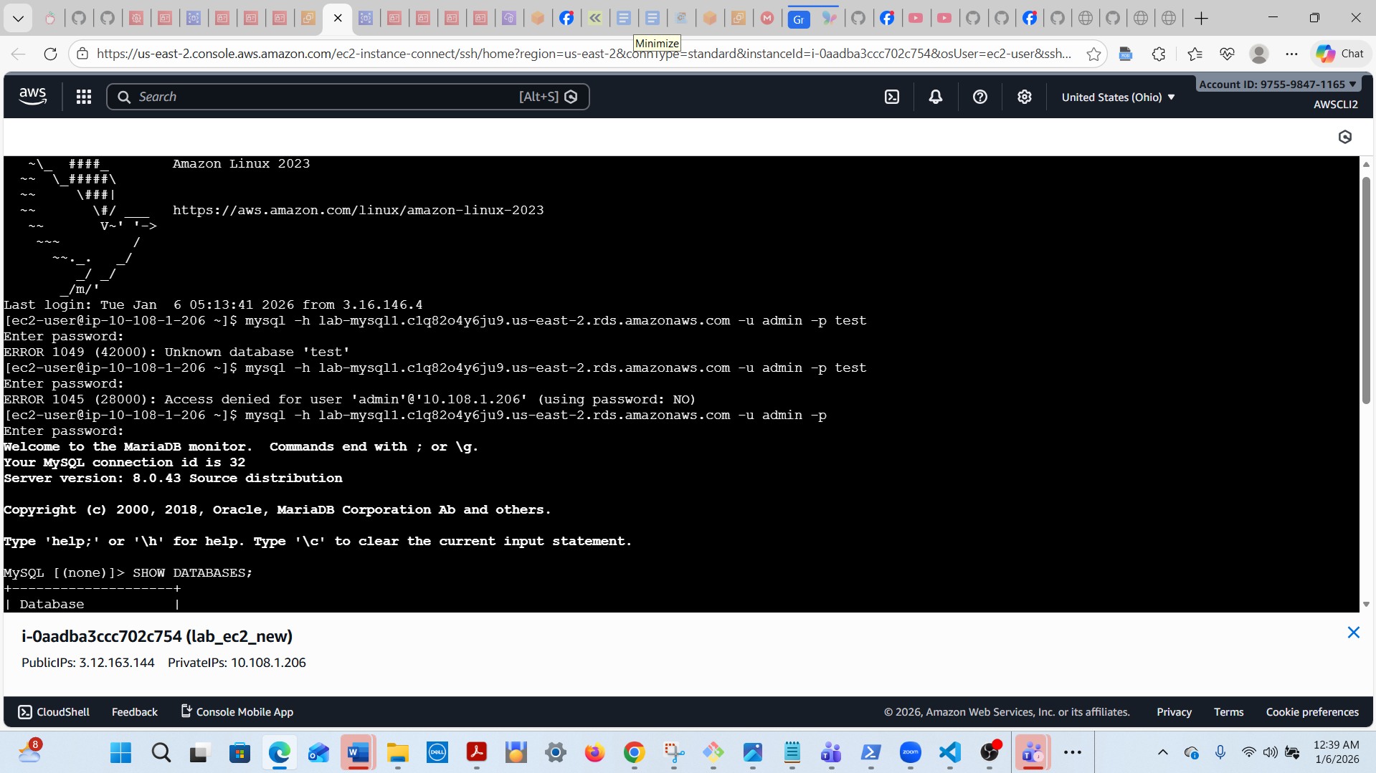

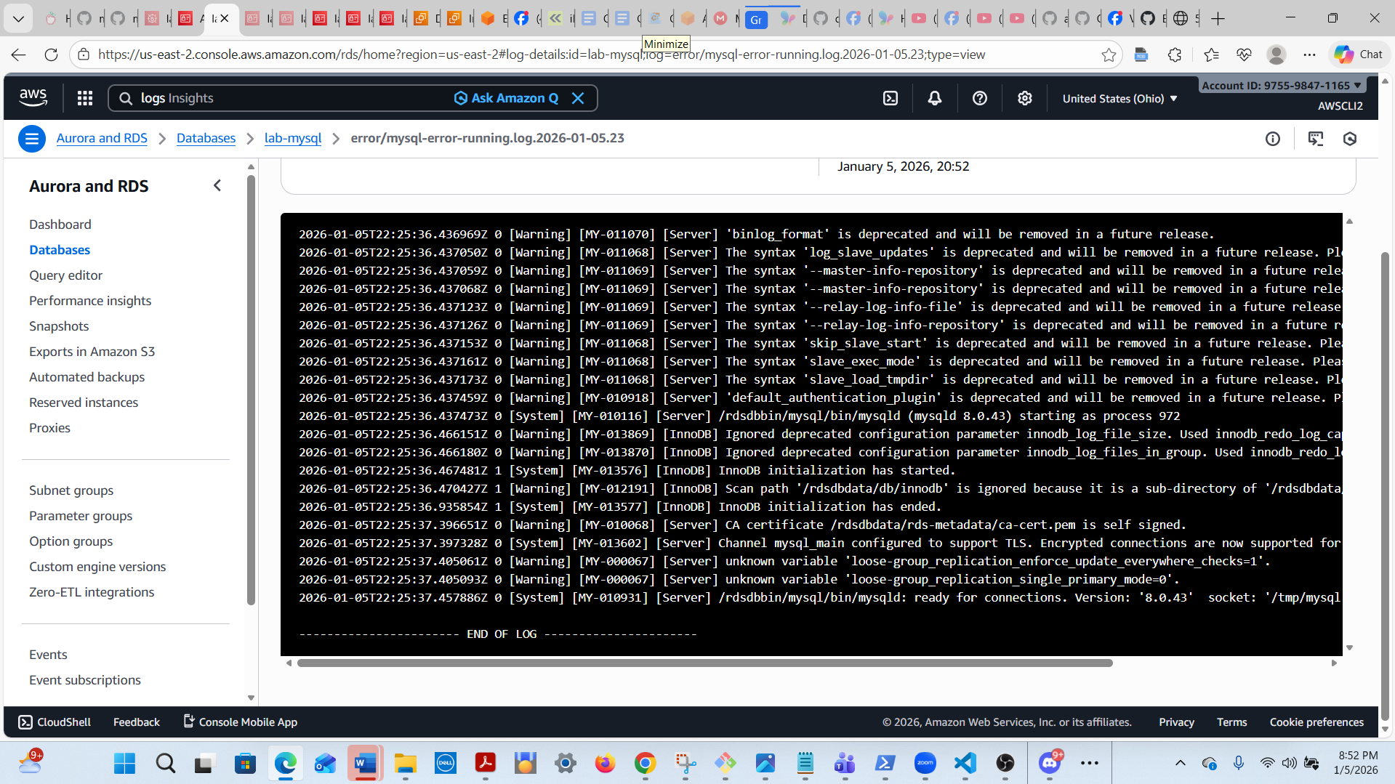
Run these commands after you connect to the database (black screen/ bird icon):
account number: 975598471165

lab-mysql.c1q82o4y6ju9.us-east-2.rds.amazonaws.com

aws secretsmanager get-secret-value --secret-id lab/rds/MySQL

These are the endpoint commands for the database:
mysql -h lab-mysql.c1q82o4y6ju9.us-east-2.rds.amazonaws.com
-u admin -p

SHOW DATABASES;

CREATE DATABASE labdb;

systemctl start rdsapp

After you update the database by adding a line, run the first command below:
sudo systemctl restart rdsapp

add?note=cloud_labs_are_real

aws rds describe-db-instances --db-instance-identifier lab-mysql --query "DBInstances[].Endpoint"

aws secretsmanager get-secret-value \
--secret-id lab/rds/MySQL

mysql -h lab-mysql1.c1q82o4y6ju9.us-east-2.rds.amazonaws.com -u admin -p test

